Table of Contents
1 Yahoo 2
2 Gmail 4
3 Hotmail 6

Yahoo
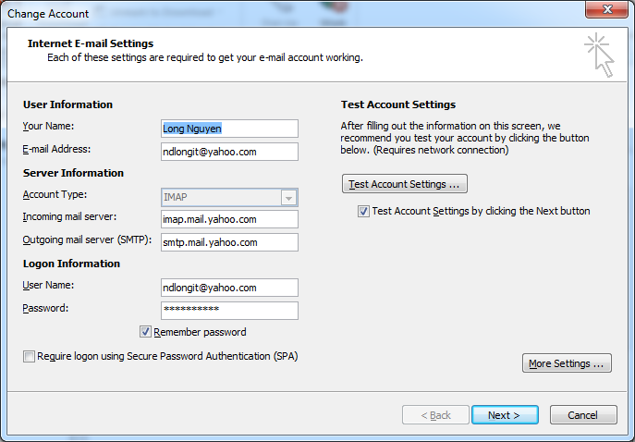
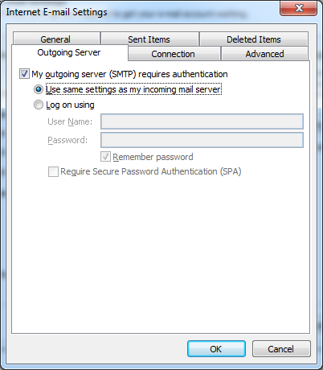
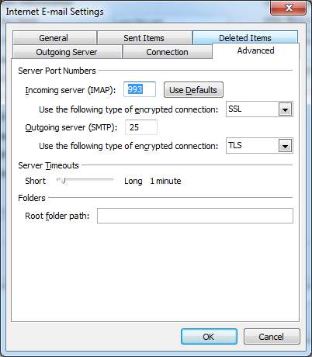

Gmail
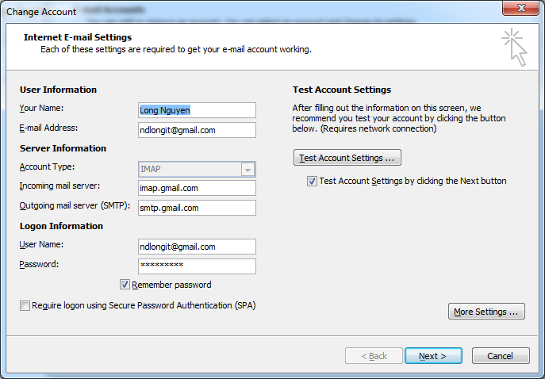

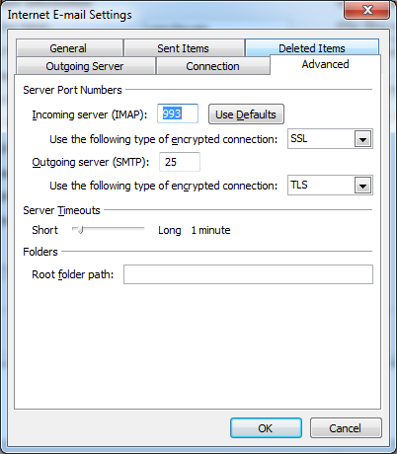

Hotmail
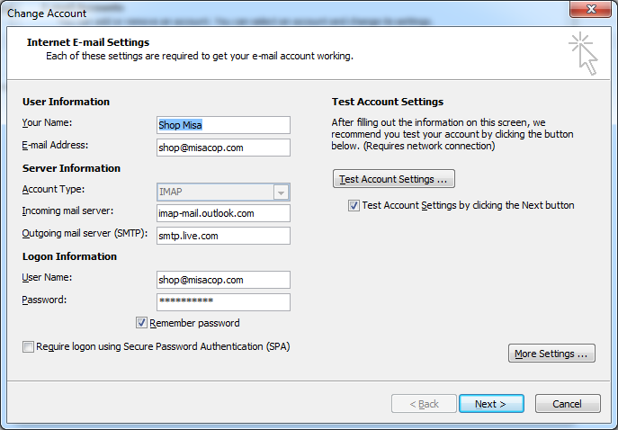
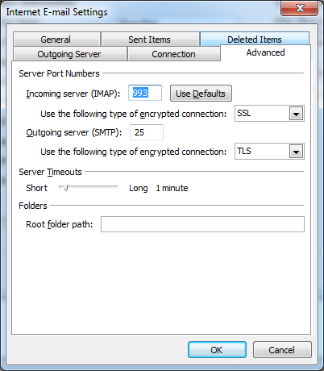

Office 365
 | Server name | Port | Encryption method
POP3 | outlook.office365.com | 995 implicit | TLS* v1-1.2
IMAP4 | outlook.office365.com | 993 implicit | TLS* v1-1.2
SMTP | smtp.office365.com | 587 explicit | TLS v1-1.2
